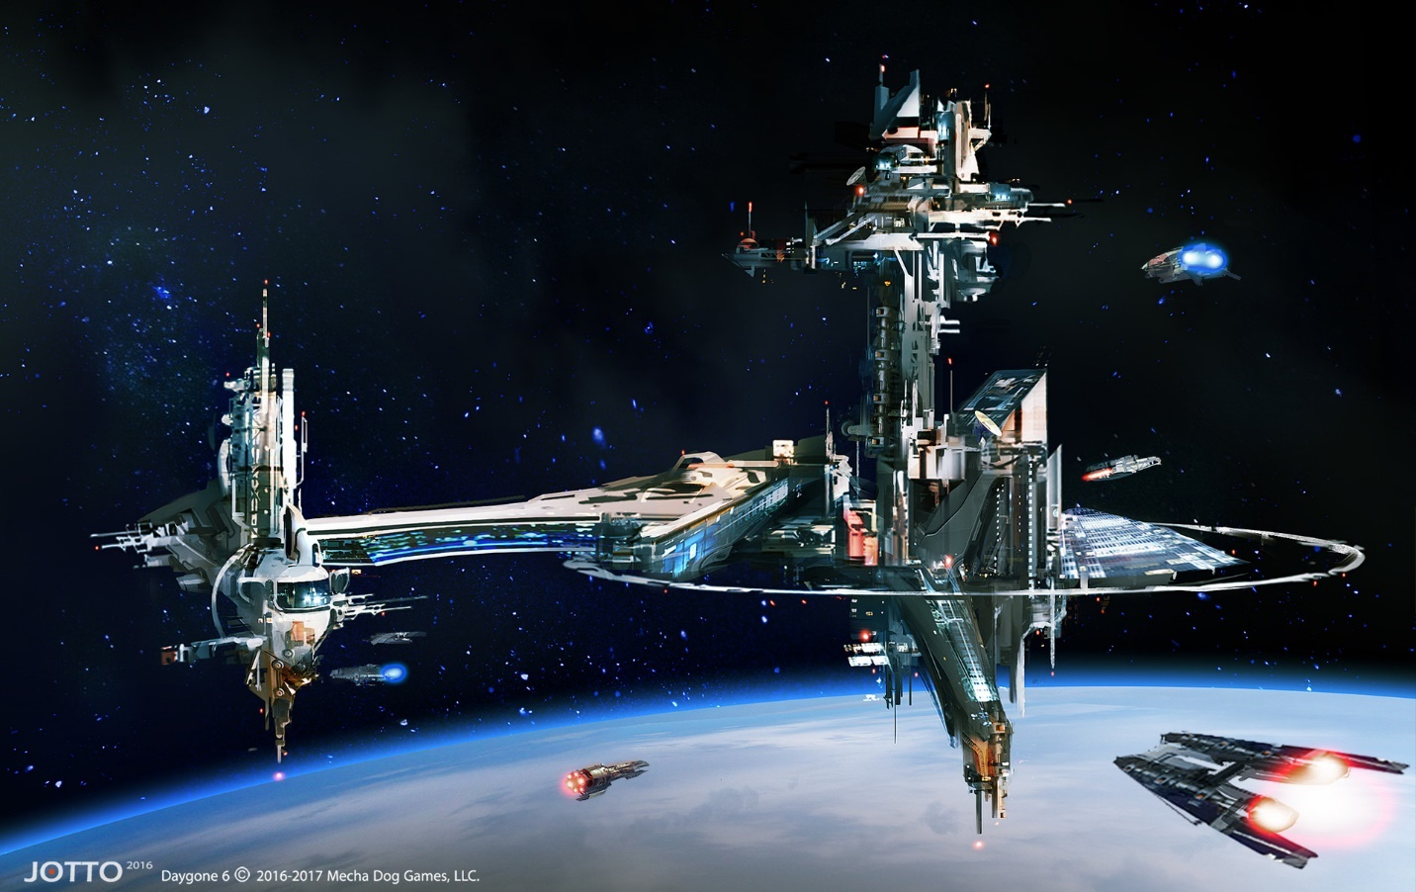

[Cover Image]

Dying Light: Space to Base

Version 1.0

|  |  |
| --- | --- |
| Designer: | Aiwen “Emily” Zhang |
| Document Date: | October 2nd, 2023 |
| Intended Level Delivery Date: | December 4th, 2023 |

**Document Revisions Table**

|  |  |  |  |
| --- | --- | --- | --- |
| **Version** | **Description** | **Requestor** | **Date** |
| 1.0 | Initial Document | Professor Stephens | October 2nd, 2023 |
|  |  |  |  |
|  |  |  |  |
|  |  |  |  |
|  |  |  |  |

## Table of Contents

Table of Contents 2

Table of Figures 3

Level Summary 4

Quick Summary 4

Level Feature Overview 4

Development Schedule 5

Level Overview 6

Overview Map 6

Narrative Flow Chart 8

Level Details 9

Detail Maps 9

Section 1 – Space Shuttle + Debris (Interior + Exterior) 9

Section 2 – International Space Station (Exterior) 11

Section 3 – Space Colony (Interior) 13

Aesthetic References 15

Visual Theme 1 – Space Colony 15

Visual Theme 2 – Space Station 16

References 17

Appendices 19

Appendix A: New Skills / Gameplay Mechanics 19

Appendix B: Context Detail 19

General Context 19

Backstory 19

Aftermath 19

Narrative Summary 19

Appendix C: Character Descriptions 19

Appendix D: Dialog Flow 19

Appendix E: Development Risks 20

Appendix F: Key Asset Needs 21

## Table of Figures

Figure 1 Overview Map (Exterior + Interior) [12] 6

Figure 2 Level Narrative Overview [13] 8

Figure 3 Space Shuttle and Debris Detailed Map [12] 9

Figure 4 Space Station Detailed Map [12] 11

Figure 5 Space Colony Detailed Map [12] 13

Figure 7 Contact Sheet Visual Theme 1 - Space Station [2-11] 15

Figure 8 Contact Sheet for Visual Theme 2 - Space Station [2-11] 16

# Level Summary

## Quick Summary

*Space to Base* is a standalone *Dying Light* custom map that takes place in space. The Player plays the protagonist, Crane, who mysteriously wakes up in a space incident, who is trying to reach the dock of the nearest space colony and escape this situation.

This level consists of prolonged parkour sequence, including traversing floating objects, and a zombie chase scene. This level also consists of a small varieties of zombie enemies that infested the space colony. The Player needs to defeat the enemies in order to get to the escape pod.

## Level Feature Overview

|  |  |  |
| --- | --- | --- |
| Category | Sub-Category | Feature List |
| Player | Player Weapons | * Crowbar * Baseball bat * Firecracker * Dynamite |
|  | Player Skills/Abilities | * Floating Object Parkour * Breaking Glass to access in accessible areas * Perform consecutive parkour sequence to escape from a chase scene |
| AI | Enemies | * Virals * Biter * Bomber |
|  | Friendlies | Radio Voice |
| Challenges | Gameplay Themes | * Prolonged parkour sequence * Short burst of parkour chase * Floating object parkour |
|  | Obstacles/Hazards | * Floating Objects * Fire * Drop beneath the floating object to death zone |
|  | New/Unique Gameplay | * Floating object parkour * Fire hazard |
| Context | Where Fits in Game | * Early game |
|  | Challenge Fit | * Easy to Medium |
|  | Additional Info | * The level takes place in Space, which is an unconventional context for the base game |
| Aesthetics | Major Visual Themes | * Outer Space * Space Colony & Space Stations * Space Debris |
|  | Setting/Mood | * Lonely * Spaciousness * Intense |

## Development Schedule

|  |  |
| --- | --- |
| Milestone | Date |
| LDD | October 2nd, 2023 |
| Whitebox | October 16th, 2023 |
| Initial Gameplay | November 6th, 2023 |
| Gameplay Complete | November 20th, 2023 |
| Aesthetics | November 27th, 2023 |
| Launch | December 4th, 2023 |

## Level Overview

### Overview Map

4

15

14

13

12

11

10

9

8

7

6

5

3

2

1

Figure Overview Map (Exterior + Interior) [12]­

|  |  |
| --- | --- |
| Map Label | Gameplay Summary |
| 1 | The player starts off in a broken space shuttle bedroom, with one side of the wall broken. The Player looks to the window on the right shows the spacecraft the Player needs to reach to leave. |
| 2 | The Player reaches the opening of the broken space shuttle, looking to the debris of space, the Player climbs onto the debris rocks. |
| 3 | The Player reaches a space to fight off a Biter, then take the med kit. The Player continues to climb the debris. |
| 4 | The Player boards the International Space Station, the Player faces three more Biters and a Viral. From there the Player can reach a keycard for an elevator |
| 5 | When the Player reaches the elevator, the Player can reach the higher tower of the Space Station. |
| 6 | After facing 4 more Biters in the Tower, the Player can climb up the zipline and zipline to the bottom part of the Space Station. |
| 7 | Upon reaching the lower part of the Space Station, the Player can pick up a new weapon, parkour through the solar panels, and faces 4 enemies. (Here is the start of the side quest on the corpse) |
| 8 | The Player can see the remaining of the Space Colony, and a keycard on the way. |
| 9 | The Player picks up the keycard on the way to the Space Colony and enter the house of the Space Colony. |
| 10 | Upon entering the house, the Player faces 3 Biters in the house. The Player can see a ledge that they can climb upon. |
| 11 | After climbing up the ledge, it’s a hallway that’s broken. The Player goes into the room and picks up the note. Upon picking up the note, a Viral breaks through the wall and starts chasing the Player. |
| 12 | When the Player is escaping, there will be two more Virals chasing the Player, breaking out from the side rooms in the hallway. |
| 13 | At the end of the hallway, the Player enters a vent that leads them to the courtyard of the Space Colony. |
| 14 | Entering the courtyard, the Player sees a Bomber, and several Virals on the ground, and several biters on the roof of the courtyard houses. The Player can defeat them with the melee weapons, and zip around the courtyard using the rooftop ziplines. |
| 15 | After defeating all the enemies, the Player can pickup the keycard near the door, and reach the broken patio. From the patio, the Player can zipline back to the spacecraft to escape. |

## Narrative Flow Chart

Figure Level Narrative Overview [13]

# Level Details

## Detail Maps

### Section 1 – Space Shuttle + Debris (Interior + Exterior)

**

3a

3

2c

2b

2a

2

1c

1b

1a

1

Figure Space Shuttle and Debris Detailed Map [12]

|  |  |  |
| --- | --- | --- |
| Map Label | Event Summary | Event Details |
| 1 | Player starts the map. The radio tells him to get out of the shuttle. | Player wakes up in a broken space shuttle, the Player sees a space craft outside the window, but they cannot reach it. |
| 1a | Player realizes there’s no other way to get to the spacecraft unless leaving the shuttle. | The Player picks up the keycard and a weapon on the table. |
| 1b | Player needs to leave the shuttle. | The Player vaults over a floating object. |
| 1c | Player needs to climb on the floating debris in order to get to the next place. | The Player faces their first enemy, the Player kills the enemy.  **Enemy: 1 x Biter** |
| 2 | Player picks up a med kit. | The Player picks up a med kit from the table and sees a Biter.  **Enemy: 1 x Biter** |
| 2a | Player kicks the Biter down the hole. | The Player can kick the Biter down the broken wall into space. The Player can reach for the first debris rock. |
| 2b | Player climbs and kicks down another Biter. | Upon climbing multiple floating rock platforms, the Player meets another Biter and fights it.  **Enemy: 1 x Biter** |
| 2c | Player picks up another med kit. | After fighting the Biter, the Player has a chance to pickup a floating med kit.  **Pickup: Med Kit** |
| 3 | Player reaches a safe space and defeats a Biter and picks up another med kit. | After a series of floating rocks, the Player reaches a larger platform for a safe place, where the Player meets another Biter and another med kit.  **Enemy: 1 x Biter**  **Pickup: Med Kit** |
| 3a | The Player faces another Biter on the debris. | Leaving the safe platform, the Player meets another Biter on the floating rock before reaching the next section.  **Enemy: 1 x Biter** |

### Section 2 – International Space Station (Exterior)

5a

7b

7a

6

5

4c

4b

4a

9

8

7

4

Figure Space Station Detailed Map [12]

|  |  |  |
| --- | --- | --- |
| Map Label | Event Summary | Event Details |
| 4 | Player reaches the International Space Station following the floating rocks. | Player steps foot on the Space Station for the first time, seeing enemies populates through their path. Player will also see a Viral for the first time. |
| 4a | Player faces the Viral for the first time. | Player encounters a viral, they can either run away or kicks the Viral off the Space Station bridge. The Player will also encounter two other Biters.  **Enemy: 1 x Viral; 2 x Biter** |
| 4b | Player needs to get to the elevator through these floating objects. | Player encounters one Biter and grabs a med kit. The Player can also see the zipline going from the top of the tower to the bottom section of the Space Station.  **Enemy: 1 x Biter** |
| 4c | Player needs to grab the keycard to access the elevator. | The Player encounters a Bomber for the first time and the Player needs to grab the keycard to access the elevator.  **Enemy: 1 x Bomber**  **Pickup: 1 x Keycard** |
| 5 | Player meets the Bomber for the first time. Seeing that they need to reach the tower to use the zipline to the bottom part of the Space Station | The Player encounters and defeats the Bomber, then the Player is able to reach the top section via the elevator by using the keycard they’ve collected in the previous step. The elevator takes them to the top section of the Space Station. |
| 5a | The Player gets to the higher part of the Space Station, they need to reach the zipline. | The Player encounters 4 more Biters and needs to fight them off before reaching the tower for the zipline.  **Enemies: 4 x Biter** |
| 6 | Player uses the zipline to reach the lower section of the Space Station. | The player climbs up the tower and is able to use the zipline on top of the tower. The Player is then able to reach the lower section of the Space Station. |
| 7 | Places reaches the lower level of the Space Station, seeing the remain of the Space Colony. | Upon reaching the lower section of the Space Station, the Player can pickup a new melee weapon, and they’ll see more enemies on the way to the Space Colony remains. |
| 7a | Player meets more enemies on their way. | Player uses melee weapons to defeat more Biters on the way, or the Player can kick them off the edge and send them to death.  **Enemy: 2 x Biter** |
| 7b | The player reaches a med kit and meets more enemies. Side quest is also available here. | Player can approach the corpse on this platform and starts the side quest of the level. The Player needs to fight off another enemy and pick up the med kit.  **Enemy: 1 x Biter** |
| 8 | Player gets closer to the remain of the Space Colony. | Player encounters more enemy and med kit before starting to approach the Space Colony  **Enemy: 1 x Biter** |
| 9 | Player reaches the broken part of the Space Station and picks up a keycard. | The Player almost reaches the Space Colony, and they can pick up the keycard to enter the house on the remains of the Space Colony.  **Pick up: 1 x Keycard** |

### Section 3 – Space Colony (Interior)

11a

15

11a

10b

10a

10

14

13

12

11

Figure Space Colony Detailed Map [12]

|  |  |  |
| --- | --- | --- |
| Map Label | Event Summary | Event Details |
| 10 | Player enters the house and meets more enemies. | Player uses the keycard to enter the house, where the Player finds more Biters and the Player needs to defeat them.  **Enemy: 3 x Biter** |
| 10a | Player parkours and climbs the ledge to reach a higher hallway. | Player notices the stacked objects that leads to the higher platform and climbs up the objects, reaching a hallway that’s exposed to the lower floor. |
| 10b | Player goes into the room to pick up the note. | Player enters the room at the end of the hallway and enters the room to pickup the note.  **Pick up: 1 x Note** |
| 11 | A Viral starts chasing the Player. | Upon picking up the note, the wall will start breaking and a Viral will break free from the other side of the wall. |
| 11a | Another Viral starts chasing the Player, there can be two Virals that is chasing the Player. | As the Player drops down to the other side of the house, and parkours through the obstacles, more Virals breaks free from the side rooms and start chasing the Player.  **Enemy: 3 x Virals** |
| 12 | Player can find the side quest’s quest item in this room. | If the Player enters the room, that’s where the Player can finish the side quest by inspecting the body and pick up the note on the table.  **Pick up: 1 x Note** |
| 13 | Player climbs up into the vent. | The Player can follow the stacked objects and climb up to the vent on the ceiling. |
| 14 | Player leaves the vent and reaches a house courtyard area. | The vent leads the Player to the exterior courtyard area where the Player encounters more enemies, which the Player needs to defeat in order to leave.  **Enemy: 1 x Bomber; 6 x Biter; 2 x Viral** |
| 15 | Player leaves the courtyard area and reaches their destination to leave the scene. | After killing all the enemies, the Player needs to pickup the keycard to leave the courtyard area. At the patio, the Player sees another zipline that leads back to the space shuttle and its escape spacecraft. The level ends as the Player reaches the platform where the spacecraft is located. |

## Aesthetic References

This level consists of two major themes – Space Colony and Space Station. All of the themes revolve around the core theme of “space”. This level is inspired by two major titles – Prey (2017) and Starfield (2023).

### Visual Theme 1 – Space Colony

Figure Contact Sheet Visual Theme 1 - Space Station [2-11]

### Visual Theme 2 – Space Station

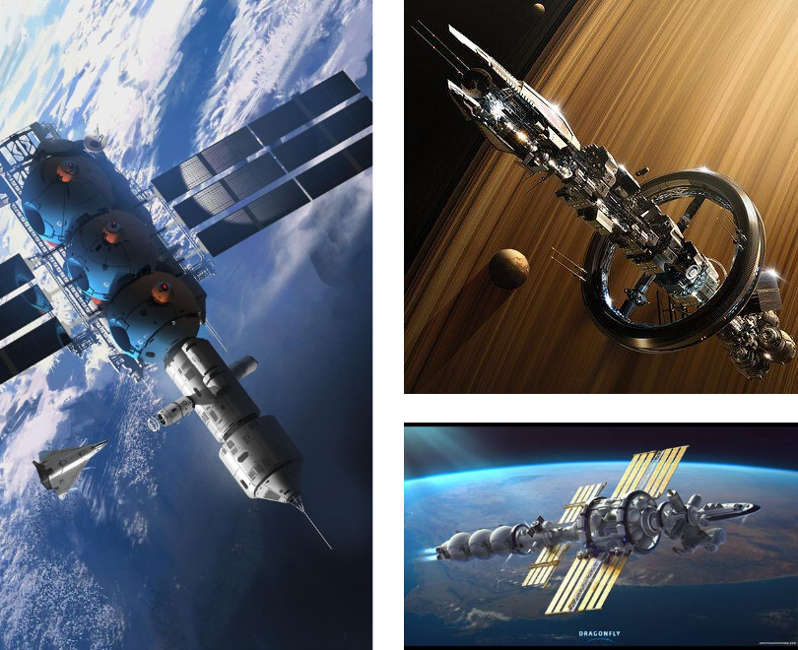

Figure Contact Sheet for Visual Theme 2 - Space Station [2-11]

# References

[Cover Image] “Space Station, J.Otto Szatmari,” ArtStation, Jun. 02, 2017. https://www.artstation.com/artwork/X0zvw (accessed Sep. 07, 2023).

[1] “Spirit free icon designed by Smashicons,” Flaticon. Accessed: Sep. 30, 2023. [Online]. Available: <https://www.flaticon.com/free-icon/spirit_2834701?term=death&page=1&position=41&origin=search&related_id=2834701>

[2] roguetelemetry, “Rogue_Telemetry,” Tumblr. Accessed: Sep. 20, 2023. [Online]. Available: <https://roguetelemetry.tumblr.com/post/126532847475/run2damoon-sirsalis-colony-by-alexey>

[3] “Pinterest,” Pinterest. Accessed: Sep. 20, 2023. [Online]. Available: <https://www.pinterest.com/emily1331923/ld3-space-to-base/space-colony/>

[4] “Pinterest,” Pinterest. Accessed: Sep. 20, 2023. [Online]. Available: <https://www.pinterest.com/emily1331923/ld3-space-to-base/space-colony/>

[5] “Pinterest,” Pinterest. Accessed: Sep. 20, 2023. [Online]. Available: <https://www.pinterest.com/emily1331923/ld3-space-to-base/space-colony/>

[6] “Notes free icon designed by Freepik,” Flaticon. Accessed: Sep. 30, 2023. [Online]. Available: <https://www.flaticon.com/free-icon/notes_768818?term=note&page=1&position=1&origin=search&related_id=768818>

[7] “Mitchell Stuart,” ArtStation. Accessed: Sep. 20, 2023. [Online]. Available: <https://www.artstation.com/mitcharts>

[8] “Hospital free icon designed by Good Ware,” Flaticon. Accessed: Sep. 27, 2023. [Online]. Available: <https://www.flaticon.com/free-icon/hospital_687529?term=health&page=1&position=11&origin=search&related_id=687529>

[9] “Granite free icon designed by Freepik,” Flaticon. Accessed: Sep. 26, 2023. [Online]. Available: <https://www.flaticon.com/free-icon/granite_6224567?term=stone&page=1&position=2&origin=search&related_id=6224567>

[10] “Dragonfly Ship Concept by JonathanDufresne on DeviantArt.” Accessed: Sep. 20, 2023. [Online]. Available: <https://www.deviantart.com/jonathandufresne/art/Dragonfly-Ship-Concept-704099223>

[11] “Dana’s Station, Paul Chadeisson,” ArtStation. Accessed: Sep. 20, 2023. [Online]. Available: <https://www.artstation.com/artwork/3ddGA>

[12] Zhang, Emily, created with Adobe Illustrator, created on September 30th, 2023.

[13] Zhang, Emily, created with Diagrams.net, created on September 30th, 2023.

# Appendices

## Appendix A: New Skills / Gameplay Mechanics

N/A

## Appendix B: Context Detail

### General Context

### Backstory

### Aftermath

### Narrative Summary

N/A

## Appendix C: Character Descriptions

N/A

## Appendix D: Dialog Flow

N/A

## Appendix E: Development Risks

|  |  |  |  |
| --- | --- | --- | --- |
| Map Label | Description/Mitigation | Type | Priority |
| 1-4 | Overscoping | Production | High |
| All | Lighting causing performance issues | Performance | Medium |
| All | Respawn point and checkpoints inconsistent | Scripting | High |

## Appendix F: Key Asset Needs

|  |  |  |
| --- | --- | --- |
| Description | Type | Priority |
| Cranes, Towers and Metal Tubes | SM Asset | High |
| Metal Mesh Floors and Walls | SM Asset | High |
| Glass Windows and Glass Walls (destructible) | SM Asset | High |
| Locked Doors and Keycard | Scripting logic | High |