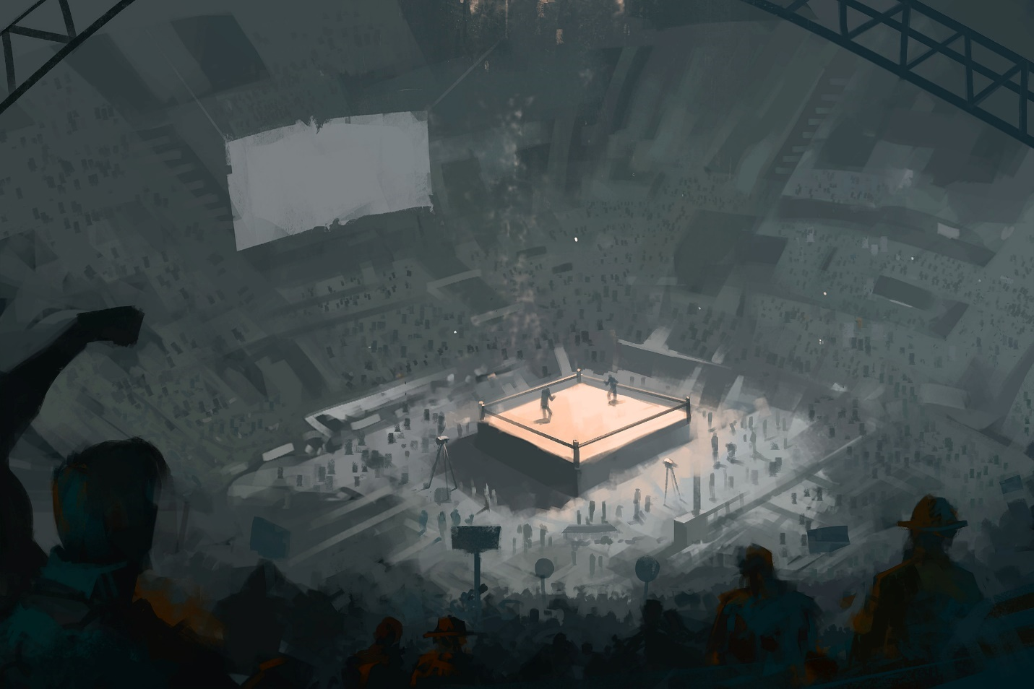

[cover Image]

Fallout 4: Fist to Fist

Version 1.0

|  |  |
| --- | --- |
| Designer: | Emily Zhang |
| Document Date: | 2/20/2023 |
| Intended Level Delivery Date: | 5/1/2023 |

**Document Revisions Table**

|  |  |  |  |
| --- | --- | --- | --- |
| **Version** | **Description** | **Requestor** | **Date** |
| 1.0 | Initial Document | Professor Ouellette | 2/20/2023 |
|  |  |  |  |
|  |  |  |  |
|  |  |  |  |
|  |  |  |  |

## Table of Contents

Table of Contents 2

Table of Figures 4

Level Summary 5

Quick Summary 5

Level Feature Overview 6

Development Schedule 7

Level Overview 8

Red Rocket 8

Overview Map – Exterior 9

Overview Map - Interior 10

Narrative Flow Chart 12

Level Details 13

Detail Maps 13

Red Rocket 13

New Mong Kok Town (Exterior Ground Floor) 14

Crimson Creed Entrance Overview (Ground Floor) 16

Crimson Creed Entrance – Bar 16

Crimson Creed Underground Fighting Club - Overview (BG1) 18

Crimson Creed Underground Fighting Club - Overview (BG2) 19

Crimson Creed Underground Fighting Club – Balcony (BG1) 20

Crimson Creed Underground Fighting Club – Brian’s Cell (BG1) 21

Crimson Creed Underground Fighting Club – Arena (BG2) 23

Crimson Creed Underground Fighting Club – Locker Room (BG2) 23

Crimson Creed Underground Fighting Club – Storage Room (BG2) 26

Crimson Creed Underground Fighting Club - Backroom (BG1) 26

Crimson Creed Underground Fighting Club – Backroom 2 (BG1) 27

Skill Progression Chart 29

Aesthetic References 30

Visual Theme 1 – Exterior: New Mong Kok City Streets 30

Visual Theme 2 – Interior: Underground Fighting Club 31

References 32

Visual Theme References 32

Other References 33

Appendices 35

Appendix A: New Skills / Gameplay Mechanics 35

Mechanic A – Power Fists 35

Mechanic B – Hand to Hand Combat 35

Appendix B: Context Detail 36

General Context 37

Backstory 37

Aftermath 37

Narrative Summary 38

Choices Analysis 40

Appendix C: Character Descriptions 41

NPC 1: Jake Bradley 41

NPC 2: Brian Hong 41

NPC 3: Froggy 42

NPC 4: Freddie Hong 42

Appendix D: Dialog Flow 43

Appendix E: Development Risks 44

Appendix F: Key Asset Needs 45

## Table of Figures

Figure 1 Fist to Fist Quest Map Overview (Exterior + Interior) [22] 8

Figure 2 Red Rocket Exterior Overview Map [22] 8

Figure 3 New Mong Kok Exterior Map [22] 9

Figure 4 Crimson Creed Interior Overview Map [22] 10

Figure 5 Simplified Narrative Flow Chart [24] 12

Figure 6 Red Rocket Exterior Detailed Map [22] 13

Figure 7 New Mong Kok Exterior Detailed Map [22] 14

Figure 8 Crimson Creed Entrance Overview Map [22] 16

Figure 9 Crimson Creed Entrance Detailed Map [22] 16

Figure 10 Crimson Creed BG1 Overview Map [22] 18

Figure 11 Crimson Creed BG2 Overview Map [22] 19

Figure 12 Crimson Creed BG1 Balcony Detailed Map [22] 20

Figure 13 Crimson Creed BG1 Brian's Cell Detailed Map [22] 21

Figure 14 Crimson Creed BG2 Arena Detailed Map [22] 23

Figure 15 Crimson Creed BG2 Locker Room Detailed Map [22] 23

Figure 16 Crimson Creed BG2 Storage Room Detailed Map [22] 26

Figure 17 Crimson Creed BG1 Backroom Detailed Map [22] 26

Figure 18 Crimson Creed BG1 Backroom 2 Detailed Map [22] 27

Figure 19 Fist to Fist Skill Progression Chart [23] 29

[Figure 20 Contact Sheet for Visual Theme 1 - Exterior 30](https://smu365-my.sharepoint.com/personal/aiwenz_smu_edu/Documents/LD2/LDD/ZhangA_FistToFist_LDD.docx#_Toc127728838)

[Figure 21 Contact Sheet for Visual Theme 2 - Interior 31](https://smu365-my.sharepoint.com/personal/aiwenz_smu_edu/Documents/LD2/LDD/ZhangA_FistToFist_LDD.docx#_Toc127728839)

Figure 22 Fist to Fist General Narrative Information Flowchart [24] 36

Figure 23 Pros and Cons Analysis of the Player's choices 40

# Level Summary

## Quick Summary

*Fist to Fist* is a *Fallout 4* single-player, standalone mod that takes place in the streets of New Mong Kok and the underground fighting ring that was ran by the local gang – the Red Dragons. The story of the level tells the story of how an unfortunate man and an aspiring pro fighter are caught up in the gang war between two local gangs. This level is designed to recreate the gang war situations and to highlight to unique gameplay of melee-heavy combat in the underground fighting ring. Additionally, the underground fighting ring level is designed to have a central landmark structure of the fighting ring that constantly has action happening in the middle of the building. The player should be able to see the fighting ring from different angles of the building throughout the quest.

## Level Feature Overview

|  |  |  |
| --- | --- | --- |
| Category | Sub-Category | Feature List |
| Player | Player Weapons | * Power Fist * Stealth Knife * Combat Rifle * Double-barrel Shotgun |
|  | Player Skills/Abilities | * Melee combat with Power Fist * Hand to hand combat in the boxing ring * Unlock doors with keys and terminals * Lockpicking for extra rewards |
| AI | Enemies | * The Red Dragon Goons * The Flying Lotus Goons * Jake Bradley * Brian Hong |
|  | Friendlies | * New Mong Kok villagers * The Red Dragon (depends on player choice) * The Flying Lotus (depends on player choice) |
| Challenges | Gameplay Themes | * Hand to Hand combat leading to the major decision * Stealth and Shoot-out playstyle compatible levels * Faction change depending on the player decision |
|  | Obstacles/Hazards | * Locked Doors (Terminal locked & Key locked) |
|  | New/Unique Gameplay | * Custom Weapon – Power Fist: knocks enemies far back and staggers them as part of the combat. It can be combined with the landscape to knock them far enough down the ditch and set them on fire. |
| Context | Where Fits in Game | * Standalone side quest that can be complete at any given player level |
|  | Challenge Fit | * The challenge of the game is on combat and space navigation, primarily focusing on melee hand-to-hand combat and ranged shoot-out combat. * It fits in early-mid stage of the main game as it requires basic understanding of terminal reading, and door unlocking mechanics. * The main quest and the fun of the game can also be experienced by late-game, high-level player characters as it is story-based and navigation-heavy. |
|  | Additional Info | * Based on the player’s choice, there will be a change of faction stance, the player will be faced with a different combat sequence * The player’s decision will also result in different major character’s death |
| Aesthetics | Major Visual Themes | * Exterior: Goodneighbor, a lot of civilians walking around, there is a market/bar area with people talking and chatting, there are other houses scattered in the area * Interior: Underground club, fancy and well-lit with a central spotlight on the fighting ring; constructed with industrial/brick mod kit and some interior furniture; office rooms and cell rooms included |
|  | Setting/Mood | * Exterior: Populated with villagers and by-standers, sometimes there are fights breaking out in the streets, it is definitely a busy town * Interior: Heavily guarded by The Red Dragons, but a lot of rich-looking audience sitting inside placing bets, a juxtaposition to the settings and mood on the outside |

## Development Schedule

|  |  |
| --- | --- |
| Milestone | Date |
| LDD | 2/20/2023 |
| Whitebox | 3/6/2023 |
| Initial Gameplay | 3/27/2023 |
| Gameplay Complete | 4/17/2023 |
| Aesthetics | 4/24/2023 |
| Launch | 5/1/2023 |

## Level Overview

Figure 1 Fist to Fist Quest Map Overview (Exterior + Interior) [22]

### Red Rocket

**0v**

Figure 2 Red Rocket Exterior Overview Map [22]

### Overview Map – Exterior

**16v**

**5v**

**4v**

**3v**

**2v**

**1v**

Figure 3 New Mong Kok Exterior Map [22]

### Overview Map - Interior

**14d**

**14cv**

**7v**

**14e**

**14bv**

**14av**

**15v**

**14v**

**11v**

**13v**

**12v**

**10v**

**9v**

**8v**

**6v**

**5v**

Figure 4 Crimson Creed Interior Overview Map [22]

|  |  |
| --- | --- |
| Map Label | Gameplay Summary |
| 0 | Player talks to Quest Giver Freddie Hong, the leader of Flying Lotus, to accept the quest.  Car teleport enabled.  Map Marker to New Mong Kok added on the map.  Player activates the car teleporter to teleport to New Mong Kok. |
| 1 | Player arrives at the main gate of New Mong Kok.  Player follows the narrow alleyway to reach the center plaza of New Mong Kok. |
| 2 | Player arrives at the center plaza of new Mong Kok.  Player sees a big water tower in front of them. |
| 3 | Player talks to Froggy sitting on the bar stool.  Froggy tells the player more detail about the quest, and gives them a ticket to the Crimson Creed.  Froggy tells player to go to Crimson Creed. |
| 4 | Player follows the path to get to Crimson Creed Entrance. |
| 5 | Player enters the Crimson Creed, the entrance to the underground fighting ring is to the right.  Player can optionally talk to the bar tender to ask for the entrance. |
| 6 | Player talks to the guard, who grants the player passage to the underground fighting ring. |
| 7 | When Player enters the Underground fighting ring, the Player sees Jake defeats his opponent in the ring with strong force. |
| 8 | Player goes to talk with Brian, learning about his purpose here and why is he in jail. Brian wants the Player to talk to Jake about the Power Fist. |
| 9 | Player goes to talk with Jake, learning about his undefeated streak and his powerful fist. Jake suggests the player finds answers in the Ring Master’s office. |
| 10 | Player reaches the Ring Masters office, finding clues about the Power Fist. |
| 11 | Brian asks the player to fight Jake for him to find out more about the Power Fist. |
| 12 | Player defeats Jake in the fighting ring and Jake tells him to not let the Power Fist go to the wrong hands. |
| 13 | As the next champion of the fighting ring, the Player goes against Brian, and Brian let slip information about what the Flying Lotus is planning on doing with the Power Fist.  Player defeats Brian in the ring and decides whether to kill Brian in the ring to keep the secret of the Power Fist within the Red Dragons or let Brian live to tell the Flying Lotus about the Power Fist. |
| 14 | [Kills Brian] Player talks to the Ring Master. Ring Master tells you to leave through the locker room but might meet with resistance |
| 14a | Defeats all the enemies in the Arena level. |
| 14b | Kills two guards in the locker room, get the key from the guard and enters the next room. |
| 14c | Kills all the enemies in this room, access the next room upstairs using the terminal to unlock the door. |
| 14d | Kills all the enemies in this room. [Optional] Unlock the other entrance to Brian’s cell using a key on the enemy. |
| 14e | Kills all enemies in the next room after following the corridor, gets the key from one of the enemies and exit to the entrance of Crimson Creed. [Goes to Step 16] |
| 15 | [Let Brian Live] Player talks to the Ring Master. Ring Master knows you stole the secrets. Ring Master launches an attack on you. |
| 15a | Same as 14a to 14e. |
| 16 | Player speaks with Freddie Hong. |

## Narrative Flow Chart

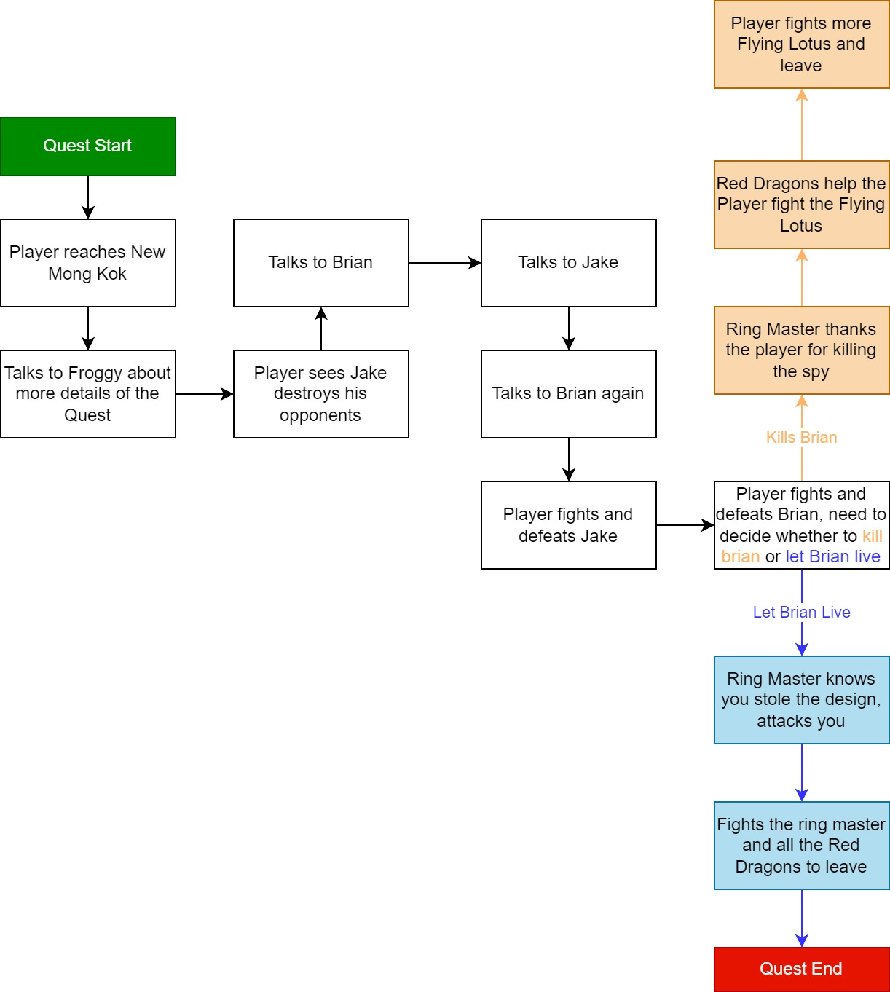

Figure 5 Simplified Narrative Flow Chart [24]

# Level Details

## Detail Maps

### Red Rocket

**0a**

**0**

Figure 6 Red Rocket Exterior Detailed Map [22]

### New Mong Kok Town (Exterior Ground Floor)

**3**

**2a**

**1a**

**2**

**1**

Figure 7 New Mong Kok Exterior Detailed Map [22]

|  |  |  |  |
| --- | --- | --- | --- |
| Map Label / Stage | Event Summary | Event Details | Approx Difficulty (1-10) |
| 0 | Meet Freddie Hong near his car at Red Rocket | Key Objective:   * Talks to Freddie about the Quest * Activates Map Marker on Pip Boy, **gives the location of New Mong Kok** * Tells the player to **find Froggy** in New Mong Kok   Conveyance:   * **Red Car** * **Three suit-up men** standing next to it looking ominous   Note: If Player decides to not take quest, the quest will not start. | 0 |
| 0a | Use the car to get to New Mong Kok | Key Objective:   * Activate the car to **teleport to New Mong Kok** * **Arriving at the gate** of New Mong Kok   Conveyance:   * Freddie tells the player his men will drive them to New Mong Kok * Black car surrounded by two suited men | 0 |
| 1 | Reach New Mong Kok | Key Objective:   * **Enter the gate** of New Mong Kok * Follow the narrow alleyway to **get to the main plaza** of the town   Conveyance:   * **Neon light signaling** the gate and inside the allyway * **Sight-lining the narrow alleyway** with no other possible paths | 0 |
| 1a | Explore New Mong Kok | Optional Objective:   * Talk to the townspeople about their current lives * Learn more about the Red Dragons | 0 |
| 2 | Talk to Froggy | Key Objective:   * Get **Crimson Creed ticket** from Froggy * Learn about the informant, Brian, and why he is in there   Conveyance:   * **Only one person** sitting by the water tower bar * Should be the first thing **directly in the players view using framing technique**   Key Item(s): Ticket to Crimson Creed (Note) | 0 |
| 2a | Sees the Sign that is near Crimson Creed | **Big Nuka Cola billboard sign** conveys the player’s next location at the other end of the town | 0 |
| 3 | Enter Crimson Creed | Key Objective:   * **Enter the Interior** of Crimson Creed   Conveyance:   * Nuka Cola Billboard | 0 |

### Crimson Creed Entrance Overview (Ground Floor)

Figure 8 Crimson Creed Entrance Overview Map [22]

### Crimson Creed Entrance – Bar

**5**

**4**

Figure 9 Crimson Creed Entrance Detailed Map [22]

|  |  |  |  |
| --- | --- | --- | --- |
| Map Label / Stage | Event Summary | Event Details | Approx Difficulty (1-10) |
| 4 | At the Entrance of Crimson Creed | Conveyance:   * **A red door** with a guard is to the right of the bar * **A bar tender** directly in front of the player’s view | 0 |
| 5 | Talk to Guard | Key Objective:   * **Talk to the Guard** about **entering the underground fighting ring** with the ticket * Player **learns more about the underground fighting ring** from the guard   Conveyance:   * **Guard** is guarding a red door * **Red door** with an exit sign * **The bar tender will tell you** that is the entrance to the underground fighting ring | 0 |

### Crimson Creed Underground Fighting Club - Overview (BG1)

Figure 10 Crimson Creed BG1 Overview Map [22]

### Crimson Creed Underground Fighting Club - Overview (BG2)

](https://smu365-my.sharepoint.com/personal/aiwenz_smu_edu/Documents/LD2/Deconstruction/ZhangA_%20FO4_Deconstruction.docx?web=1)

Figure 11 Crimson Creed BG2 Overview Map [22]

### Crimson Creed Underground Fighting Club – Balcony (BG1)

**6**

Figure 12 Crimson Creed BG1 Balcony Detailed Map [22]

### Crimson Creed Underground Fighting Club – Brian’s Cell (BG1)

**10**

**7**

Figure 13 Crimson Creed BG1 Brian's Cell Detailed Map [22]

|  |  |  |  |
| --- | --- | --- | --- |
| Map Label / Stage | Event Summary | Event Details | Approx Difficulty (1-10) |
| 6 | Enter the Underground Fighting Ring (BG1) | Key Narrative Moment:   * **Using the framing technique**, Player immediately sees **Jake fighting in the ring** on the floor below, devastatingly **strong against his opponent**.   Key Objective:   * Player learns about the existence of Jake and his strong boxing glove * Player sees the space for the first time | 0 |
| 7 | Talk to Brian | Key Narrative Moment:   * **Meets with Brian** and learns about *why he is here*, *how he was caught*, and *what the player can do to help him*   Key Objective:   * Brian tasks the Player to **talk to Jake**, the formidable, priced fighter of the Red Dragons * **Give Player the key to Ring Master’s Storage room**   Key Item(s): Ring Master’s Storage Room Key | 0 |

­

### Crimson Creed Underground Fighting Club – Arena (BG2)

**14`**

**13`**

**12`**

**11`**

**9**

Figure 14 Crimson Creed BG2 Arena Detailed Map [22]

### Crimson Creed Underground Fighting Club – Locker Room (BG2)

**15`**

**8**

Figure 15 Crimson Creed BG2 Locker Room Detailed Map [22]

|  |  |  |  |
| --- | --- | --- | --- |
| Map Label / Stage | Event Summary | Event Details | Approx Difficulty (1-10) |
| 6 | Enter the Underground Fighting Ring (BG1) | Key Narrative Moment:   * **Using the framing technique**, Player immediately sees **Jake fighting in the ring** on the floor below, devastatingly **strong against his opponent**.   Key Objective:   * Player learns about the existence of Jake and his strong boxing glove   Player sees the space for the first time | 0 |
| 7 | Talk to Brian | Key Narrative Moment:   * **Meets with Brian** and learns about *why he is here*, *how he was caught*, and *what the player can do to help him*   Key Objective:   * Brian tasks the Player to **talk to Jake**, the formidable, priced fighter of the Red Dragons * **Give Player the key to Ring Master’s Storage room**   Key Item(s): Ring Master’s Storage Room Key | 0 |
| 8 | Talk to Jake | Key Narrative Moment:   * Learn *why Jake is here fighting for the Red Dragons* * **Learn about the Power Fist**   Key Objective:   * Jake tells the Player **to find more answers at the Ring Master’s office** | 0 |
| 9 | Go to Ring Masters Room  (Ring Master Absent) | Key Objective:   * Player **unlocks the Ring Master’s Storage Room** with the key (given by Brian) * Enter the Ring Master’s Office through the storage room * **Search the office for notes** about the design of Power Fist and how the Red Dragons are using it   Conveyance:   * Locked door of the storage room is **blue** * Player is able to see inside the Ring Master’s room via **windows/cracks on the wall** * Note should be placed **on the office desk**   Key Item(s):   * Note on the design of the Power Fist (x1) * Note on how they are testing the Power Fist (x 1) | 1 |
| 10 | Talk to Brian again (Map in Figure 12) | Key Narrative Moment:   * Brian tells the Player they need to **fight Jake for the Player** to get the Power Fist   Key Objective:   * Tell Brian the Player has **gotten the design notes** | 0 |
| 11 | Fight Jake in the Boxing Ring | Key Narrative Moment:   * Jake tells the player **do not let the Power Fist fall into the wrong hands**   Key Objective:   * **Defeat Jake for Brian** in a hand-to-hand combat   Key Item(s): Player **receives Power Fist** from Jake  Note: All the Player’s weapons and armors will be sorted and put in a locker container in the locker room upon entering the ring | 2 |
| 12 | Fight Brian in the Boxing Ring | Key Narrative Moment:   * Decision Point:   + Kill Brian [Option 1]   + Let Brian Live [Option 2]   Key Objective:   * Fight Brian until Brian is at Bleed Out state | 1 |
| 13 | Speak with the Ring Master | Key Objective:   * [Option 1] Ring Master thanks you for getting rid of the spy in the area**, the Red Dragons will help the Player fight the incoming Flying Lotus** * [Option 2] Ring Master knows the Player has stolen from his office, started a fist fight with the Player**, the Player defeats the Ring Master and try to make their way out, the Flying Lotus assists** | 0 |
| 14 | Battle in the Arena | Key Objective:   * **Get to the Locker Room** for the Player’s weapons and armors   Key Enemies:   * BG1 – Balcony: Ranged x 4, Melee x 1 * BG2 – Arena: Ranged x 3, Melee x 2   Note: The Player who has ranged weapons can choose the shoot out method to get to the Locker Room, otherwise, the Player can use the stealth approach. | 3 |
| 15 | Go to Locker Room | Key Objective:   * Kill both enemies guarding the door * Retrieve the key on the enemy to unlock the door * Retrieve all player items   Key Enemies:   * Melee Enemies x 2 | 1 |

### Crimson Creed Underground Fighting Club – Storage Room (BG2)

**16a**

**16`**

Figure 16 Crimson Creed BG2 Storage Room Detailed Map [22]

### Crimson Creed Underground Fighting Club - Backroom (BG1)

**17`**

**17a**

Figure 17 Crimson Creed BG1 Backroom Detailed Map [22]

### Crimson Creed Underground Fighting Club – Backroom 2 (BG1)

**19`**

**18a**

**18`**

Figure 18 Crimson Creed BG1 Backroom 2 Detailed Map [22]

|  |  |  |  |
| --- | --- | --- | --- |
| Map Label / Stage | Event Summary | Event Details | Approx Difficulty (1-10) |
| 16 | Fight all Enemies in the Room | Key Enemies:   * Ranged x 1 * Melee x 3   Player **encounters the Ranged Enemy first**, can be defeated using the Power Fist, and then **encounter the three melee enemies with easy difficulty**. | 2 |
| 16a | Unlock Door using Terminal | Player unlocks the door leading upstairs using the Terminal | 1 |
| 17 | Fight all Enemies in the Room | Key Enemies:   * Ranged x 2 * Melee x 1   This is an **easier encounter with less enemies**, more encounter with the ranged enemies than melee. The Player **can use the Power Fist** to counter these enemies. | 1 |
| 17a | [Optional] Unlock door to Brian’s Cell | Optional Objective:  Player can choose to unlock the door to Brian’s cell with a key found on an enemy | 0 |
| 18 | Fight all Enemies in this Room | With the **hallway space for the Player to recover and reload**, the Player enters the final combat room.  Key Enemies:   * Ranged x 2 * Melee x 2   A **Ranged enemy is further away** and is **holding their position** in the corner. That is the enemy holding the key to the exit door. The player can again counter the Melee enemies using the Power Fist. | 2 |
| 18a | Retrieve Key to Exit from Enemy | **Loot the Exit door key from the enemy** and unlock the exit door. | 0 |
| 19 | Exit to Crimson Creed lobby | **Release the chains on the Exit door** on the Ground Floor and exit to the lobby of Crimson Creed bar. | 0 |

## Skill Progression Chart





Figure 19 Fist to Fist Skill Progression Chart [23]

## Aesthetic References

There are primarily two visual themes for this level – one exterior and one interior.

The exterior theme is inspired by Diamond City and Goodneighbor in the main game with some neon art style inspirations from cyberpunk themes. The idea is to get a tight-knitted town with a lot of populations and a busy atmosphere around the area. The player should get a sense that it is not so safe of a community and a lot of crimes and bad things can happen here.

The interior theme is inspired by underground jazz clubs and underground boxing clubs. As shown in the reference contact sheet, the interior area should be an underground area with tall ceilings and a fighting ring in the middle of the space. Bars and seatings are available for people to sit and converse. The goal is to create a juxtaposing mood with the exterior, showing the corruption and underground scene of the town.

### Visual Theme 1 – Exterior: New Mong Kok City Streets­

Figure 20 Contact Sheet for Visual Theme 1 - Exterior

### Visual Theme 2 – Interior: Underground Fighting Club

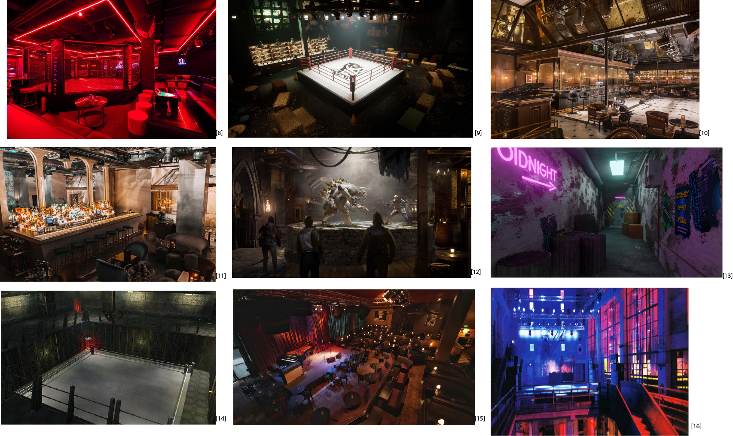

Figure 21 Contact Sheet for Visual Theme 2 - Interior

## References

[Cover Image] “The Finale, Ayan Nag,” ArtStation, Jul. 24, 2016. https://www.artstation.com/artwork/16Woo (accessed Feb. 19, 2023).

### Visual Theme References

[1] “0e29777f8fc846c59965b33cade15254.jpg (1536×2044).” https://i.pinimg.com/originals/0e/29/77/0e29777f8fc846c59965b33cade15254.jpg (accessed Feb. 13, 2023).

[2] “12577570f8e5ad33ad75ad1a9d2f894c.jpg (1362×2048).” https://i.pinimg.com/originals/12/57/75/12577570f8e5ad33ad75ad1a9d2f894c.jpg (accessed Feb. 13, 2023).

[3] “Check Out Shanghai’s Very Own Underground Fight Club,” SmartShanghai. https://www.smartshanghai.com/articles/nightlife/on-the-radar-punch-cage-fight-club (accessed Feb. 13, 2023).

[4] J. Luster, “Classic Boxing Manga Ashita no Joe Inspires New TV Anime,” Otaku USA Magazine, Oct. 13, 2017. https://otakuusamagazine.com/ashita-no-joe-inspires-new-anime/ (accessed Feb. 13, 2023).

[5] “CLUBBING IN BERLIN!. Even if you don’t like clubs, you can… | by Riya Sharma | Medium.” https://medium.com/@sharmariya697/clubbing-in-berlin-aeb8cd537723 (accessed Feb. 13, 2023).

[6] “ddec1858c44676cf5b45672ee9420a0c1364047623_full.jpg (600×375).” https://img1.ak.crunchyroll.com/i/spire4/ddec1858c44676cf5b45672ee9420a0c1364047623_full.jpg (accessed Feb. 13, 2023).

[7] “Fighting Ring, Yu Chao Cheng,” ArtStation, Mar. 14, 2019. https://www.artstation.com/artwork/XBDLNa (accessed Feb. 13, 2023).

[8] J. M. Reporter KOMO News, “Jazz Alley show signals return of live music to Seattle,” KOMO, Jun. 10, 2021. https://komonews.com/news/local/jazz-alley-show-signals-return-of-live-music-to-seattle (accessed Feb. 13, 2023).

[9] “Metropole Underground – new bar opens at Hyatt Regency Phnom Penh,” Asia Bars & Restaurants. https://www.asia-bars.com/2022/07/metropole-underground-new-bar-opens-at-hyatt-regency-phnom-penh/ (accessed Feb. 13, 2023).

[10] “Pinterest,” Pinterest. https://www.pinterest.com/ (accessed Feb. 13, 2023).

[11] “Power Noodles,” Fallout Wiki. https://fallout.fandom.com/wiki/Power_Noodles (accessed Feb. 13, 2023).

[12] “Shudders (old draft) - Chapter 13 - The ‘Date’ - Wattpad.” https://www.wattpad.com/874628908-shudders-old-draft-chapter-13-the-%27date%27 (accessed Feb. 13, 2023).

[13] “Underground Club Entrance,” Blender Artists Community, Jun. 28, 2020. https://blenderartists.org/t/underground-club-entrance/1237706 (accessed Feb. 13, 2023).

[14] “Underground fighting arena in Environments - UE Marketplace,” Unreal Engine. https://www.unrealengine.com/marketplace/en-US/product/underground-fighting-arena (accessed Feb. 13, 2023).

[15] “图片欣赏 _ Gamersky.com.” https://www.gamersky.com/showimage/id_gamersky.shtml?http://img1.gamersky.com/image2015/12/20151220ax_8/gamersky_029origin_057_201512201649F5C.jpg (accessed Feb. 13, 2023).

Icon References

[16] “Coding free icon designed by itim2101,” Flaticon. https://www.flaticon.com/free-icon/coding_1442977?term=terminal+computer&page=2&position=25&origin=search&related_id=1442977 (accessed Feb. 18, 2023).

[17] “Criminal Silhouette With A Knife free icon designed by Freepik,” Flaticon. https://www.flaticon.com/free-icon/criminal-silhouette-with-a-knife_39997?term=person+with+knife&page=1&position=3&origin=search&related_id=39997 (accessed Feb. 18, 2023).

[18] “Key free icon designed by Freepik,” Flaticon. https://www.flaticon.com/free-icon/key_263069?term=key&page=1&position=5&origin=search&related_id=263069 (accessed Feb. 18, 2023).

[19] “Soldier free icon designed by Freepik,” Flaticon. https://www.flaticon.com/free-icon/soldier_2040411?term=soldier&page=1&position=27&origin=search&related_id=2040411 (accessed Feb. 18, 2023).

[20] “Soldier free icon designed by Iconic Panda,” Flaticon. https://www.flaticon.com/free-icon/soldier_9766316?term=soldier&page=1&position=21&origin=search&related_id=9766316 (accessed Feb. 18, 2023).

[20] “Stairs free icons designed by Freepik,” Flaticon. https://www.flaticon.com/free-icon/stairs_1655809 (accessed Feb. 18, 2023).

[21] “User free icon designed by Freepik,” Flaticon. https://www.flaticon.com/free-icon/user_1077114?term=person&page=1&position=1&origin=search&related_id=1077114 (accessed Feb. 18, 2023).

### Other References

[22] Zhang, Emily, illustrations created by *Emily Zhang*, created in *Adobe Illustrator 2022*, February 20th, 2023.

[23] Zhang, Emily, table created by *Emily Zhang*, created in Microsoft Excel, February 20th, 2023.

[24] Zhang, Emily, chart created by *Emily Zhang*, created in *Diagrams.net*, February 20th, 2023.

# Appendices

## Appendix A: New Skills / Gameplay Mechanics

### Mechanic A – Power Fists

**Functionality:** Boxing glove weapon with a toned-down push-back enchantment that allows its user to push back enemies by a small amount, stunning them and staggering the affected actor.

**User Interface:** The custom weapon is used like a regular weapon with enchantment. The player needs to use it as a primary weapon. [Attack: Left mouse click/A button]

**Specific Stats:** [Damage: 15] [Knock Back Magnitude: 2]

**Conveyance:** The weapon emits a small white steam when it is used, it is equipped like a primary weapon.

**Feedback:** The actor being punched will be pushed back and staggered if it is affected by the weapon.

### Mechanic B – Hand to Hand Combat

**Functionality:** Get the player inventory, looping through every item of the inventory to check if the item is a weapon. If it is a weapon, move the item into a nearby container.

**User Interface:** The removal can happen on both accounts – the player can remove the weapons voluntarily or they enter the trigger to be forcefully removed.

**Specific Stats:** [Keyword property] [Item Form Property]

**Conveyance:** The locker area will be near the fighting ring for the players to deposit their weapons; the players are told to remove their weapons before fighting.

**Feedback:** Notifications will appear on the top left corner of the screen notifying the player that their weapons are being removed.

## Appendix B: Context Detail

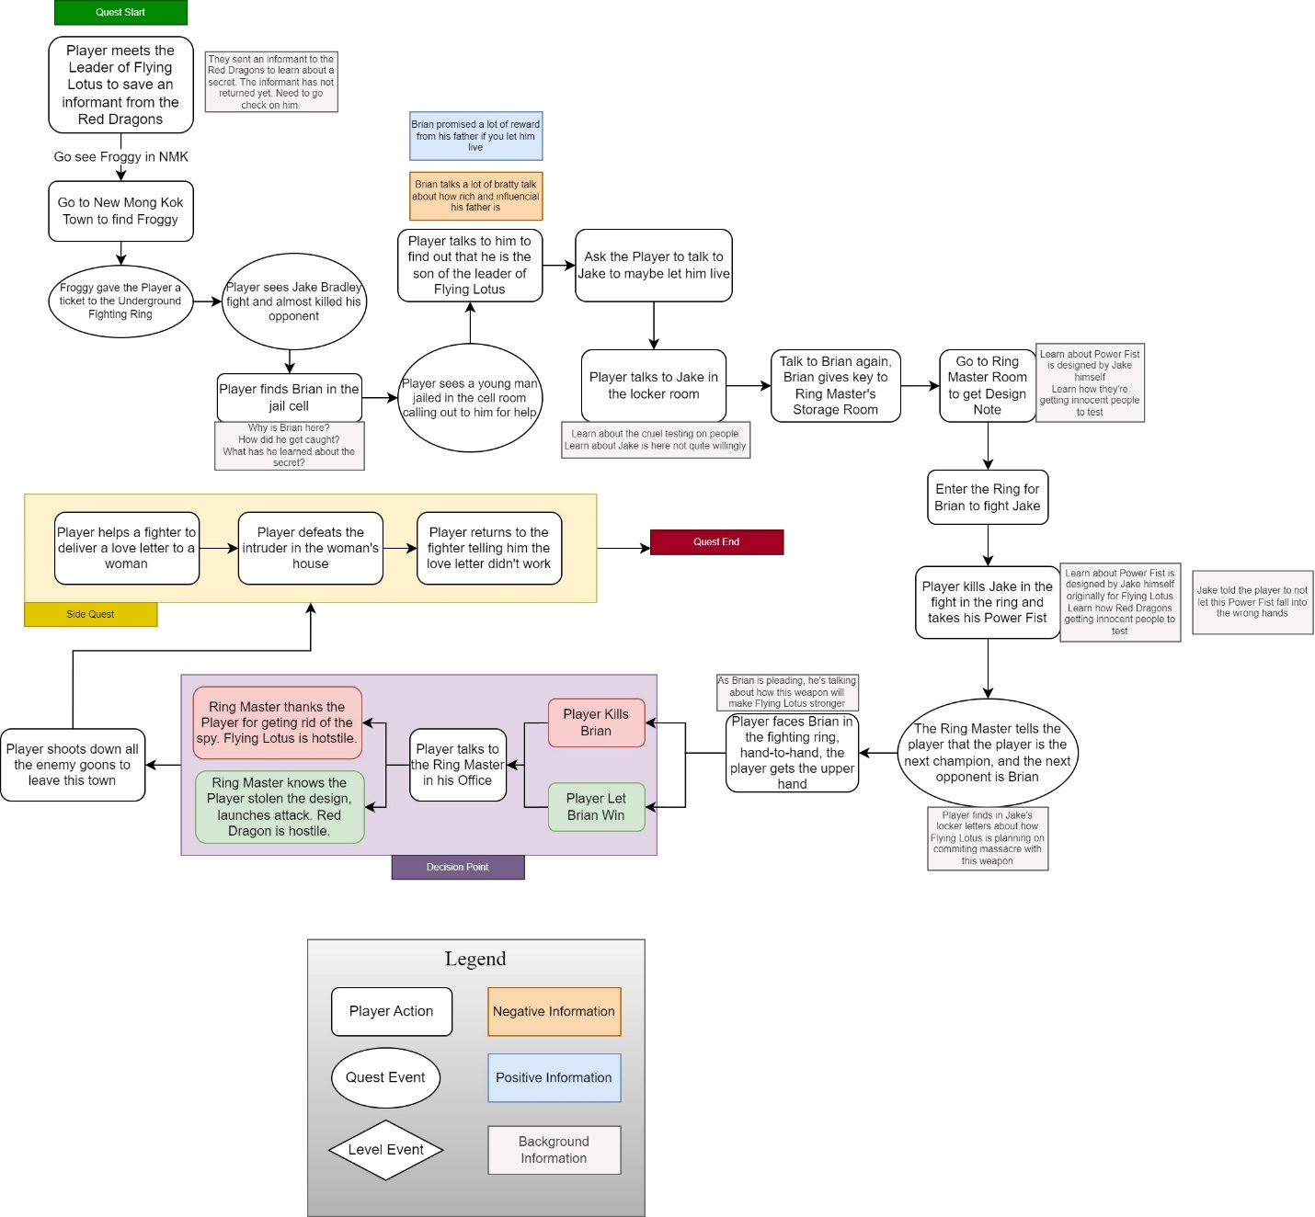

Figure 22 Fist to Fist General Narrative Information Flowchart [24]

### General Context

The town of New Mong Kok has been under the jurisdiction of The Red Dragon gang for a while. The town is filled with townspeople who are scared for their lives. Violence runs in the streets. The Flying Lotus is a rising gang running underground agricultural business in the adjacent town. The two gangs are in rivalry to each other.

The rivalry between the two gangs have come to a breaking point when the Red Dragon captured the son of the Flying Lotus’ leader’s son, who is acting as a spy trying to steal things from the Red Dragons. Since the Flying Lotus is weak in combat power, the leader has decided to hire some willing person to infiltrate the town and the underground fighting ring to rescue his son.

The Red Dragons have been using petty thieves to test their ultimate weapon, the Power Fist, killing almost all of them in the ring. The Flying Lotus wants the design of the Power Fist to strengthen the gang and spread its influence around the town.

### Backstory

Jake Bradley ended up as one of the Red Dragons when he left home after the loss of his family among the gang war. He used to be one of the best boxers in the town. The Red Dragons stroke a deal with him to provide him with food and shelter if Jake keeps testing the Power Fist on his opponents for the Red Dragons.

Brian Hong was captured by the Red Dragons when he was poking around the Red Dragon’s base and got caught. He did not let slip that he is part of the Flying Lotus, but the Red Dragons have suspected. He will be put in the fighting ring with Jake later. Before he was caught, he successfully stole one of the Ring Master’s key to his storage room. Brian also has found out some secrets about the Power Fist during his time in the underground fighting ring and is waiting to report back to his father and the Flying Lotus gang.

### Aftermath

[Brian Dies] The secret of the Power Fist stays within the Red Dragon’s base. The Flying Lotus does not get the design. The Flying Lotus wages war against the Red Dragon and the player, the player helps the Red Dragon to take out the Flying Lotus. The Red Dragon’s control over the town grows ever stronger on the livelihood of the townspeople. The Red Dragon is now forever friendly with the Player.

[Brian Lives] Brian is able to return to his father with the design of the Power Fist. The Flying Lotus can now grow stronger. The Red Dragon angrily wages war against the player and the Flying Lotus, the Flying Lotus helps the player take down the entire town of Red Dragons. The town is free of the control of the Red Dragon, but now falls into the hands of the Flying Lotus. The Flying Lotus is now forever friendly with the Player.

### Narrative Summary

|  |  |  |
| --- | --- | --- |
| Stage | Event Summary | Event Details |
| 0 | Player has not started the quest. | The Player has not yet talked to the quest giver. |
| 10 | Player has not accepted the quest. | The Player has talked to the quest giver but has not accepted the quest. |
| 100 | Player has accepted the quest. | The Player accepted the quest and started the questline, a map marker has been placed on the player’s pip-boy. |
| 200 | Travels to Quest Location | Player travels to the entrance of New Mong Kok city. |
| 300 | Talks to Froggy for further information | Froggy gives the player further information about the quest – the player needs to bribe Jake Bradley to throw a fight  [Item: Crimson Creed Pass] |
| 400 | Finds entrance to the Crimson Creed | The entrance is in a small hole-in-the-wall bar in the town. The player enters the underground club.  Upon entering the club, the player sees Jake Bradley taking out his opponent in the boxing ring, almost killing the other opponent. |
| 500 | Talk to the Guard to enter the underground fighting ring | The Guard tells you more about the Underground fighting ring, how the people make a lot of money betting, and their priced champion – Jake Bradley. |
| 600 | Find Brian | The Player finds Brian in his jail cell calling for help. Brian tells Player that he is caught stealing something from the Ring Master’s office; he is just here to try to impress his father; he saw that the Power Fist has potential. He wants the Player to talk to Jake for him. |
| 700 | Find Jake | Jake is just sitting in the locker room. Jake tells the Player the Power Fist is the property of the Red Dragons, he is just a boxer. He also tells the Player that he designed and made this, and is pretty proud of his creation. If the Player wants to learn more, he needs to go to the Ring Master. |
| 800 | Talk to Brian again | Brian says he stole the Ring Master’s storage room key and gives it to the Player. The Player can see if they can find the design note of the Power Fist from the Ring Master’s Office. |
| 900 | Find Design Note in Ring Master’s Office | The Player finds the Design note and other notes about how the Red Dragons are using petty thieves to test the Power Fist, they almost always end up dead, and they are planning on capturing innocent people next. |
| 1000 | Talk to Brian about the Design Note | Brian is happy that the Player found the design note. Now the player just must fight Jake for him because Brian is weak and incompetent. |
| 1100 | Fight Jake for Brian | When Jake is about to die, he asks player to not let the Power Fist fallen into the wrong hands. |
| 1200 | Fight Brian | As the new champion. The Player needs to fight Brian next. Brian wants the Player to let him live and throw the fight, but that means the design notes will fall into the hands of the Flying Lotus. |
| 1300 | Kill Brian [to STG1500] |  |
| 1400 | Let Brian live [to STG1600] |  |
| 1500 | Fight all the enemies [to STG1700] | The Player kills all the Flying Lotus goons outside of Crimson Creed. |
| 1600 | Fight all the enemies | The player kills all the Red Dragon goons inside and outside of the Crimson Creed. |
| 1700 | Quest Complete | Player completes the quest and leaves town. |

### Choices Analysis

|  |  |  |  |
| --- | --- | --- | --- |
| Killing Brian | | Let Brian Live | |
| Pros | Cons | Pros | Cons |
| The secret will not fall into the hand of Flying Lotus, who is trying to mass produce the weapon | The Red Dragons will continue their experiment with the Power Fist | The Secret will not fall into the hands of the Red Dragons | The Secret will fall into the hands of Flying Lotus |
|  | He’s just an innocent man who tries to impress his father | Brian can go home and impress his father with this information |  |

Figure 23 Pros and Cons Analysis of the Player's choices

## Appendix C: Character Descriptions

### NPC 1: Jake Bradley

|  |  |
| --- | --- |
| **Description** | Tough build, ragged-looking man in his 30s, wearing boxing outfit and has an enhanced boxing glove; his speech is collected and educated despite his current predicament |
| **Background** | He used to be an engineer who loves boxing. After losing his family, he turned to the Red Dragons to seek shelter and safety. His talent for boxing and engineering was noticed by the Ring Master and they put him as the key challenger and major tester for the Power Fist that Jake and the Red Dragons are developing together. |
| **Goals/Motivation** | Long-term goals:   * His love for boxing * He cares to survive in this world * His talent for engineering   Short-term goals:   * Win as many fights as possible * See justice done |
| **Personality/Archetype** | He knows what he is doing is bad, but he has no choice because I needs to survive. He loves his inventions but he secretly wants to see justice done. |
| **Relationships** | Enemy to Brian Hong  Ally to the Red Dragons  Neutral to the Player  Neutral to the Flying Lotus |

### NPC 2: Brian Hong

|  |  |
| --- | --- |
| **Description** | A pale, lean-build man who flamboyantly brags about his family a lot. He has dark hair and slim face. |
| **Background** | He is the son of a rising, influential gang called the Flying Lotus. He is a bratty teenager with a lot of money in his hands. He wanted to impress his hard-to-impress father by sneaking into the base of Red Dragons and got caught. Accidentally stumbled across the secret of the Power Fist, he thinks this is the one shot he has to impress his father. |
| **Goals/Motivation** | Wants to rise as a formidable leader of the Flying Lotus gang, proving to his father that he is a worthy candidate for the leader position |
| **Personality/Archetype** | Irritable and quick-tempered, bratty, and flamboyant. He cares little for the well-being of the people, he just wants to impress his father by all means. |
| **Relationships** | * Son of the leader of the Flying Lotus, Freddie Hong * Enemy to Jake Bradley * Neutral to the Player * Enemy to the Red Dragons |

### NPC 3: Froggy

|  |  |
| --- | --- |
| **Description** | Inside man planted in New Mong Kok by the Flying Lotus, he’s a ragged old man who likes to drink and hangs out at the bar all the time. He also is very talkative, that’s why he knows everything that goes on around this town |
| **Background** | Froggy was an old recruit of the Flying Lotus, he’s too old to be on the field so he decided to be a spy of the gang, directly taking orders from Freddie Hong. |
| **Goals/Motivation** | Wants to live a long and happy life with alcohol and women, he doesn’t care much for other things anymore. He is loyal and true to the Flying Lotus gang because it is like family. |
| **Personality/Archetype** | Laid-back, chill and talkative |
| **Relationships** | * Friendly to the Flying Lotus * Neutral to the Player * Neutral to other people * Hostile to the Red Dragon when attacking |

### NPC 4: Freddie Hong

|  |  |
| --- | --- |
| **Description** | Tall, tough-build man in his 50s, he is calm but pushy, he likes to give orders to other people |
| **Background** | He rose to the leading position after his father passed away and the gang unanimously voted for him to be in that position. He is frustrated about his son’s carelessness and ignorance and he cares about the situation with the Red Dragons a lot. |
| **Goals/Motivation** | He wants the Flying Lotus to gain more power and influence in this world. He does not think his son is a worthy leader. |
| **Personality/Archetype** | Calm, level-headed businessman who is not afraid to do what it takes to get what he wants |
| **Relationships** | * Friendly to all Flying Lotus * Neutral to the Player * Friendly to Brian Hong * Enemy to all Red Dragons |

## Appendix D: Dialog Flow

N/A

## Appendix E: Development Risks

|  |  |  |  |
| --- | --- | --- | --- |
| Map Label | Description/Mitigation | Type | Priority |
| 12, 13 | Keeping the Player and the enemy inside the boxing ring for a fight | Script | High |
| 12, 13 | Forcing the player to fight in the boxing ring after a certain quest.  Potential Alternative:  Set as quest objective and force the player to go to the ring as the objective of the stage. | Script | High |
| 14, 15 | Ensuing a fight between different factions based on the player’s decision in dialogue | Script | High |
| 13, 14 (all) | Implementing the Power Fist that feels good during gameplay | Script | High |
| 9 | Having a door locking after the player entered the room | Script | Medium |
| 14, 15 | Narrative Choice Balance:  It seems counter-intuitive for the player to make the choice in the fighting ring and then see the consequence later, after talking to the Ring Master.  Potential Solution:  Change the choice to [Whether to give the design of the Power Fist to Red Dragons or to Flying Lotus], after killing Brian. | Narrative | Medium |

## Appendix F: Key Asset Needs

|  |  |  |
| --- | --- | --- |
| Description | Type | Priority |
| Diamond City Exterior Mod Kit | Mesh | High |
| Brick Building Interior Mod Kit | Mesh | High |
| Industrial Decoration Kit | Mesh | Medium |
| Bar furniture decoration kit | Mesh | Medium |
| Custom Weapon – Power Fist | Weapon | High |
| Custom Faction – The Red Dragons | NPC | High |
| Custom Faction – The Flying Lotus | NPC | High |
| Locker Room Key | Quest Item | High |
| Ring Master’s Storage Room Key | Quest Item | High |
| Backroom 1 Key | Quest Item | High |
| Exit Key | Quest Item | Medium |